TOOLS:

**CODEPEN (for using HTML+CSS+JS)**: [codepen.io](http://codepen.io)

**JAVASCRIPT COMPILER (only JS):** <https://www.programiz.com/javascript/online-compiler/>

JavaScript (often abbreviated as JS) is a high-level, interpreted scripting language that’s part of the core technologies of the web, alongside HTML and CSS. So far, we have studied HTML + CSS, and now, we are going to understand the logic and algorithms behind the website

* HTML defines the structure of the web page.
* CSS controls the visual styling.
* JavaScript makes the page interactive and dynamic.

This is a basic example of code:

<!DOCTYPE html>

<html lang="en">

<head>

<meta charset="UTF-8">

<title>My First JavaScript Program</title>

</head>

<body>

<h1>Hello, World!</h1>

<p>Click the button to see JavaScript in action:</p>

<button onclick="sayHello()">Click me!</button>

<script>

function sayHello() {

alert("Hello from JavaScript!");

}

</script>

</body>

</html>

**VARIABLES AND CONSTANTS**

#### 

Variables are used to store data, like text, numbers… Vars can be named **VAR** and **LET**

let name = "James";

const age = 25;

var isStudent = true;

* let is used to declare variables that can be updated.
* const is used for values that shouldn’t change.
* var is an older way to declare variables, but let and const are preferred today.

Variables can be changed and manipulated, constants cannot.

**FUNCTIONS**

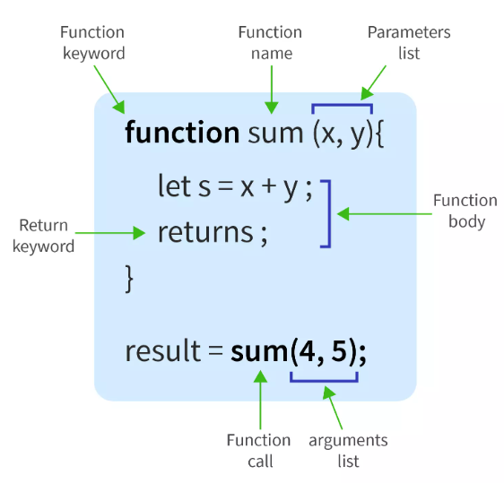

Functions are blocks of code designed to perform a task and can be reused throughout your code.

function greet(name) {

return "Hello, " + name + "!";

}

var greeting = greet("Alice"); // "Hello, Alice!"

console.log(greeting);

In this example, greet is a function that takes a name parameter and returns a greeting.

The console.log() function **outputs data to the console.**

You have a lot of functionalities in JS, you can check the documentation:

For example, The **prompt()** method displays a dialog box that prompts the user for input.

EXERCISE 1 - **Write a JavaScript function that sums two numbers and displays the result.**

EXERCISE 2 - **Write a JavaScript program that displays a greeting message with the name that user inputs.**